

**Semester 2 Examination, 2012**

**Question/Answer Booklet**

**MATHEMATICS**

**3C/3D (Year 12)**

**Section Two:**

**Calculator-assumed**

Your name: **SOLUTIONS**

Your teacher: S Ebert T Hosking S Rowden

**Time allowed for this section**

Reading time before commencing work: ten minutes

Working time for paper: one hundred minutes

**Material required/recommended for this section**

***To be provided by the supervisor***

This Question/Answer booklet

Formula sheet (retained from Section One)

***To be provided by the candidate***

Standard items: pens, pencils, pencil sharpener, eraser, correction/tape fluid, ruler, highlighters

Special items: drawing instruments, templates, notes on two unfolded sheets of A4 paper, and up to three calculators satisfying the conditions set by the Curriculum Council for this course.

**Important note to candidates**

No other items may be used in this section of the examination. It is **your** responsibility to ensure that you do not have any unauthorised notes or other items of a non-personal nature in the examination room. If you have any unauthorised material with you, hand it to the supervisor **before** reading any further.

**Structure of this paper**

|  |  |  |  |  |
| --- | --- | --- | --- | --- |
| Section | Number of questions available | Number of questions to be answered | Working time (minutes) | Marks available |
| Section One:  Calculator-free | 7 | 7 | 50 | 50 |
| Section Two:  Calculator-assumed | 13 | 13 | 100 | 100 |
|  | | | | 150 |

**Instructions to candidates**

1. The rules for the conduct of Western Australian external examinations are detailed in the *Year 12 Information Handbook 2012*. Sitting this examination implies that you agree to abide by these rules.
2. Write your answers in the spaces provided in this Question/Answer Booklet. Spare pages are included at the end of this booklet. They can be used for planning your responses and/or as additional space if required to continue an answer.

* Planning: If you use the spare pages for planning, indicate this clearly at the top of the page.
* Continuing an answer: If you need to use the space to continue an answer, indicate in the original answer space where the answer is continued, i.e. give the page number. Fill in the number of the question(s) that you are continuing to answer at the top of the page.

1. **Show all your working clearly**. Your working should be in sufficient detail to allow your answers to be checked readily and for marks to be awarded for reasoning. Incorrect answers given without supporting reasoning cannot be allocated any marks. For any question or part question worth more than two marks, valid working or justification is required to receive full marks. If you repeat an answer to any question, ensure that you cancel the answer you do not wish to have marked.
2. It is recommended that you **do not use pencil** except in diagrams.

**Section Two: Calculator-assumed (100 Marks)**



This section has **thirteen (13)** questions. Answer **all** questions. Write your answers in the space provided.

Suggested working time for this section is 100 minutes.

**Question 8 (5 marks)**

A rechargeable battery has a voltage of 9 volts when fully charged. When the battery is used to

run an electronic toy, the voltage *V* volts, remains at 9 volts for 30 minutes and then the voltage

decreases instantaneously, at a rate modelled by  where *t* is time in minutes.

(a) Find the net change in the battery voltage after the toy has been used for 40 min.

[3]



|  |
| --- |
| **Specific behaviours** |
| ✓ identified t = 10  ✓ recognised it was a total change question  ✓ correct answer, with negative sign |

(b) Find how long the battery can be used to run this toy if a minimum voltage of 8 volts is

required.

|  |
| --- |
| **Specific behaviours** |
| ✓ correct calculation either as above or from determining V(t) and using this to solve the  answer  ✓ correct answer (-1/2 if didn’t add on 30 minutes) |

[2]



Total time = 5.27 + 30 = 35.27 minutes

Question 9 (6 marks)

A body is moving in a straight line with velocity,  m/s, given by , where is the time, in seconds, since the body first passed through a fixed point P.

(a) At what other time(s), if any, does the body again pass through the fixed point P?

[3]



Hence after 4.724 and 9.526 seconds.

|  |
| --- |
| **Specific behaviours** |
| ✓ determines x(t) including acknowldging that c = 0  ✓ sets x(t) = 0  ✓ solves x(t) = 0, including acknowldeging t = 0 is an answer to the equation, and states 2 other times |

(b) Show that the body is stationary twice and find the distance travelled by the body between these two instants.

[3]



|  |
| --- |
| **Specific behaviours** |
| ✓ determines when body is stationary  ✓ Appropriate formula/calculation to determine distance  ✓ determines distance travelled between these two instances correctly |

Question 10 (7 marks)

On the basis of the results obtained from a random sample of 81 bags produced by a mill, the 95% confidence interval for the mean weight of flour in a bag is found to be (514.56g, 520.44g).

(a) Show the value of , the mean weight of the sample is 517.5 g.

[1]



|  |
| --- |
| **Specific behaviours** |
| ✓ correct answer |

(b) Find the value of , the standard deviation of the normal population from which the sample is drawn.

[2]



|  |
| --- |
| **Specific behaviours** |
| ✓ appropriate formula/calculation to determine the standard deviation  ✓ correct standard deviation |

(c) Calculate the 99% confidence interval for the mean weight of flour in a bag.

[2]





|  |
| --- |
| **Specific behaviours** |
| ✓ appropriate formula/calculation to determine the interval  ✓ correct interval |

(d) Using the sample mean from (a) as the best estimate for the population mean, what is the probability that the sample mean of a larger sample of 225 bags is less than 516 g?

[2]



|  |
| --- |
| **Specific behaviours** |
| ✓ Uses correct parameters  ✓ correct probability |

Question 11 (7 marks)

Atmospheric pressure,  (kPa), decreases approximately exponentially with increasing height  (m), above sea level according to the relationship  , where  is a constant. Atmospheric pressure at sea level is 101.3 kPa, and halves with every 5 800 m increase in height.

(a) Find the value of, rounded to four significant figures.

[2]



|  |
| --- |
| **Specific behaviours** |
| ✓ determines appropriate equation to solve  ✓ correct value of k |

(b) Calculate the atmospheric pressure at the top of a mountain of height 3 785 m.

[2]



|  |
| --- |
| **Specific behaviours** |
| ✓ Substitutes all information into equation  ✓ correct answer |

(c) Use the increments formula to find the approximate change in pressure as a climber descends 250 m from the top of a mountain of height 3 785 m.

[3]



(An increase in pressure)



(An increase in pressure)

|  |
| --- |
| **Specific behaviours** |
| ✓ identifies negative change of -250  ✓ recognises  ✓ correct answer |

Question 12 (9 marks)

(a) Even numbers are to be formed using some, or all, of the digits 5, 6, 7, 8 and 9.

(i) How many even numbers can be formed in this way, if repetition of digits is not allowed?

[3]

1-digit: 

2-digit: 

3-digit:  Total = 130 even numbers

4-digit: 

5-digit: 

|  |
| --- |
| **Specific behaviours** |
| ✓✓ for working showing number of 1, 2, 3, 4 and 5 digit numbers  ✓ correct answer |

(ii) What fraction of the numbers in (i) start with a 9? [2]

2-digit: 

3-digit: 

4-digit: 

5-digit: 

Fraction 

|  |
| --- |
| **Specific behaviours** |
| ✓ working showing number numbers starting with 9  ✓ correct answer |

(b) The journey time for a driver between two depots is normally distributed with mean of 55 minutes and standard deviation of 4.5 minutes.

(i) If the driver makes four journeys every day, for five days a week, and for 48 weeks each year, how many of these journeys take less than an hour?

[2]



|  |
| --- |
| **Specific behaviours** |
| ✓ correct probability  ✓ correctly mulitplies probability by number of journeys |

(ii) What is the probability that a journey takes at least an hour, given that it takes less than 65 minutes?

[2]



|  |
| --- |
| **Specific behaviours** |
| ✓ recognises conditional probability  ✓ correct answer |

Question 13 (12 marks)

(a) A pottery produces souvenir coffee mugs, of which it is known that 5% are defective.

(i) In a box of 24 mugs, what is the probability that there are at least 4 defectives?

[2]



|  |
| --- |
| **Specific behaviours** |
| ✓ correctly identifies the distribution and parameters  ✓ correct probability |

(ii) In a box of 12 mugs, what is the probability that there are no defectives?

[1]



|  |
| --- |
| **Specific behaviours** |
| ✓ correct probability |

(iii) What is the probability that in 10 boxes, each containing 12 mugs, that either two or three of the boxes contain no defectives?

[2]





|  |
| --- |
| **Specific behaviours** |
| ✓ correctly identifies the parameters  ✓ correct probability |

(iv) The pottery decides to pack *n* mugs per box for wholesale clients, so that the chance of there being at least one defective mug in a box is no more than 50%. Find the largest value of *n*.

[2]



|  |
| --- |
| **Specific behaviours** |
| ✓ recognises  ✓ solves for n and states correct largest value |

**Question 13 (continued)**

(b) A worker at the pottery took 150 of the defective mugs, filled them with soil and then planted four seeds in each. After 14 days, the number of seeds which germinated in each of the mugs was noted, with these results:

|  |  |  |  |  |  |
| --- | --- | --- | --- | --- | --- |
| Number of germinating seeds | 0 | 1 | 2 | 3 | 4 |
| Number of mugs | 1 | 9 | 16 | 57 | 67 |

(i) What is the mean number of seeds germinating per mug?

[1]



|  |
| --- |
| **Specific behaviours** |
| ✓ correct mean |

(ii) Show the probability of one seed germinating is 0.8.

[1]

If  is the random variable 'number of seeds germinating out of four', then assume that.  and so 

|  |
| --- |
| **Specific behaviours** |
| ✓ correct justification |

(iii) Use an associated binomial distribution to calculate the theoretical frequency distribution for the number of seeds germinating in the 150 mugs and comment on how well your distribution models the observed results above.

[3]



|  |  |  |  |  |  |
| --- | --- | --- | --- | --- | --- |
| Seeds | 0 | 1 | 2 | 3 | 4 |
| Expected | 0 | 4 | 23 | 62 | 61 |

The theoretical results are a reasonably close match to the observed results, suggesting that the binomial model is appropriate.

|  |
| --- |
| **Specific behaviours** |
| ✓ uses binomial distribution  ✓ gives expect values to whole numbers and ensure + 150  ✓ comment on distribution |

Question 14 (10 marks)

(a) A spherical snowball is melting at a rate of 18 000 cm3 per hour. At the instant the volume of the snowball is 4 000 cm3, calculate the rate of change of radius of the snowball, in cm per minute.

[4]







|  |
| --- |
| **Specific behaviours** |
| ✓ negative rate of change  ✓ correct derivative of volume formula  ✓ correct formula for  including value of radius  ✓ correct anwer in cm3/minute |

**Question 14 (continued)**

(b) (i) The area enclosed by the parabola with equation, the *x*-axis and the lines

*x* = 0 and *x* = 2 rotates about the *x*-axis. Show that the volume of this solid is

one fifth the volume of the circumscribed cylinder.

[3]

Cylinder 

Parabolic 

∴ The parabolic section is  the circumscribed cylinder

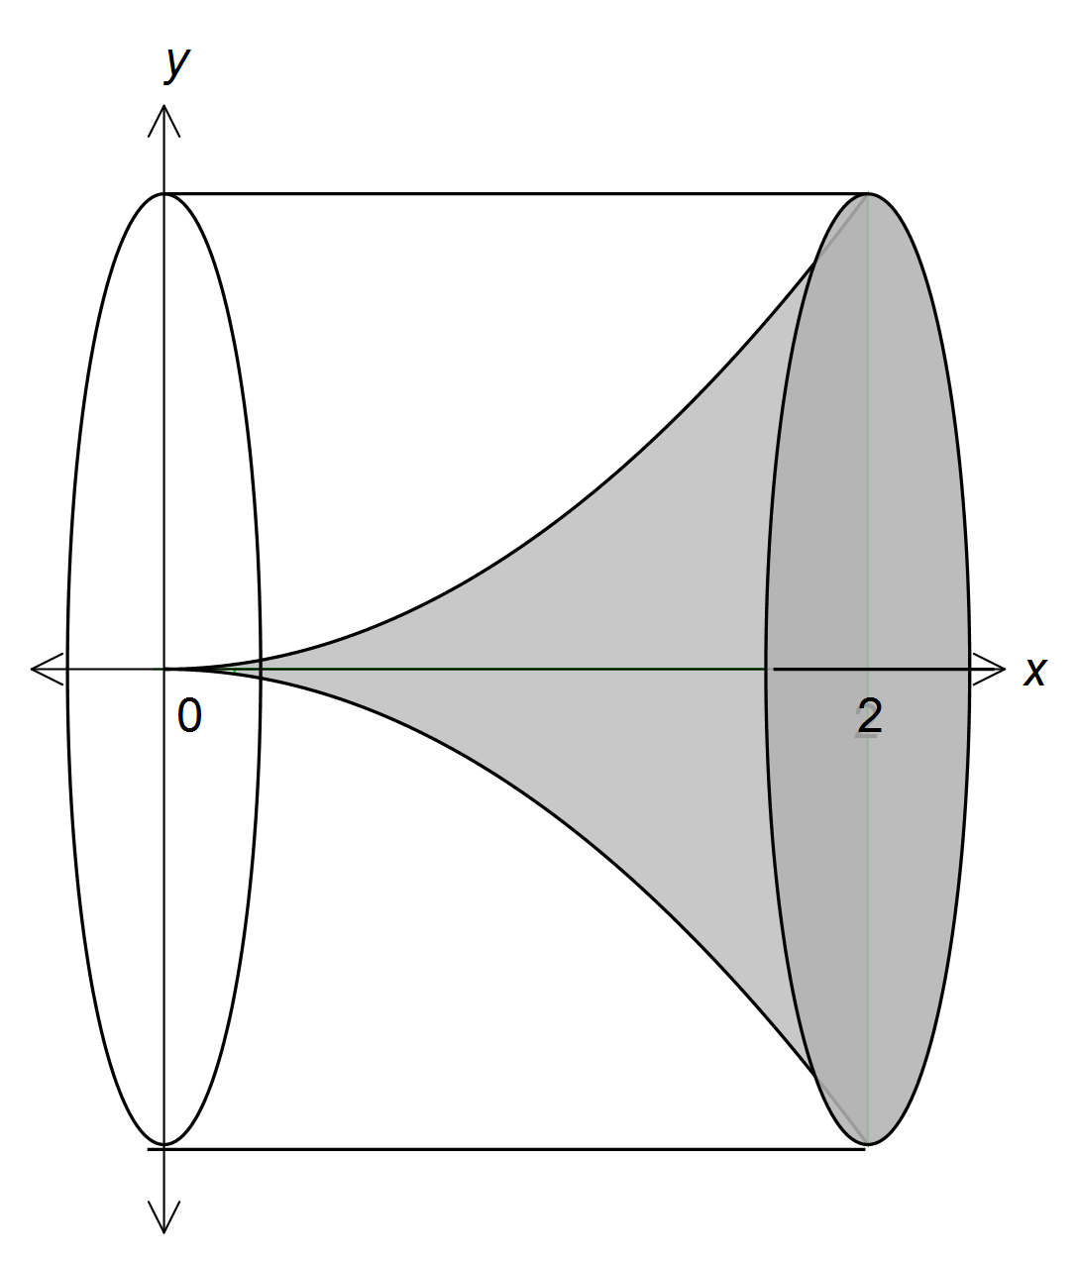

|  |
| --- |
| **Specific behaviours** |
| ✓ volume of cylinder  ✓ volume of parabolic function  ✓ comparison made and appropriate statement |

(ii) Hence, or otherwise, prove that the volume of the solid formed when rotating about the *x*-axis the area enclosed by the parabola with equation, the

*x*-axis and the lines *x* = 0 and *x* = *a*, where *a* is a positive constant, will be one fifth the volume of the circumscribed cylinder.

[3]

Cylinder 

Parabolic 

∴ The parabolic section is  the circumscribed cylinder for 0 ≤ x ≤ *a*

|  |
| --- |
| **Specific behaviours** |
| ✓ volume of cylinder in terms of *a*  ✓ volume of parabolic function in terms of *a*  ✓ comparison made and appropriate statement |

Question 15 (9 marks)

At the end of a technology course, all students sat a practical and a theory examination, with 20% achieving a distinction in the practical examination, 3% of students achieving distinctions in both examinations and 76% achieving no distinction in either examination.

(a) What is the probability that a student chosen at random from the course achieved a distinction in the theory examination?

[4]



|  |
| --- |
| **Specific behaviours** |
| ✓ determines  ✓ determines  ✓ recognises  + =  ✓ correct probability |

(b) Are the events 'achieving a distinction in the practical examination' and 'achieving a distinction in the theory examination' independent? Explain your answer.

[2]

No. From above it can be seen that .

|  |
| --- |
| **Specific behaviours** |
| ✓ calculation/explanation to justify answer  ✓ answer |

(c) In a group of 14 students who took the course, three achieved a distinction in the practical examination. If five students are selected at random from this group, what is the probability that at least two of them achieved a distinction in the practical examination?

[3]



|  |
| --- |
| **Specific behaviours** |
| ✓ determines number of combinations for 2 getting a distinction  ✓ determines number of combinations for 3 getting a distinction  ✓ correct probability |

Question 16 (5 marks)

A continuous random variable  has the probability distribution function 

(a) Calculate

(i) .

[1]



|  |
| --- |
| **Specific behaviours** |
| ✓ correct probability |

(ii) .

[2]



|  |
| --- |
| **Specific behaviours** |
| ✓ correct numerator  ✓ correct denominator |

(b) If , find the value of .

[2]



|  |
| --- |
| **Specific behaviours** |
| ✓ identifies appropriate equation to solve for k  ✓ correct value of k |

Question 17 (9 marks)

The feasible region of a linear programming problem is shown below.

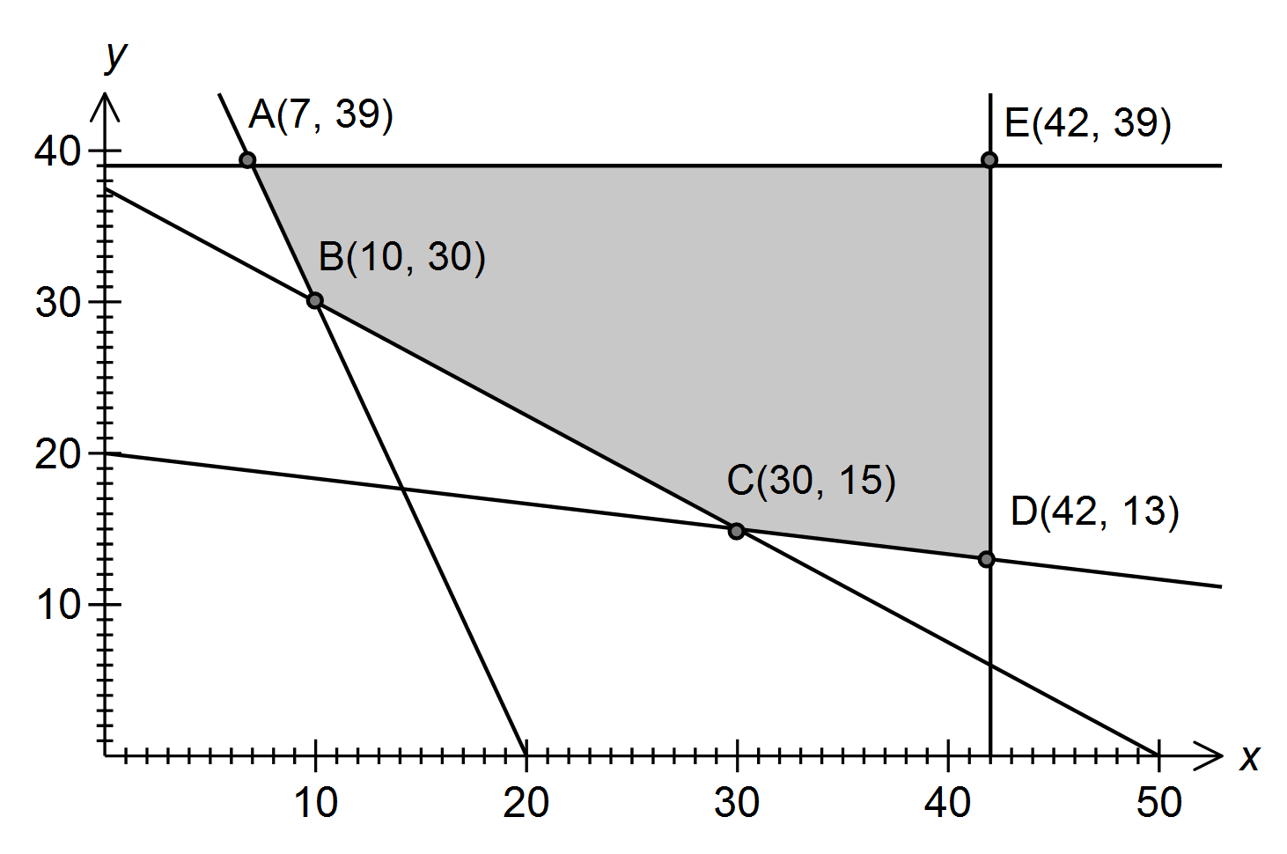

The objective function is .

(a) Determine the inequality satisfied by *x* and *y* that corresponds to the edge AB of the feasible region.

[2]



|  |
| --- |
| **Specific behaviours** |
| ✓ correct equation  ✓ correct inequality sign |

(b) Determine the maximum value of *Q* in the feasible region.

[1]



|  |
| --- |
| **Specific behaviours** |
| ✓ correct minimum |

(c) Determine the minimum value of *Q* in the feasible region.

[1]



|  |
| --- |
| **Specific behaviours** |
| ✓ correct maximum |

**Question 17 (continued)**

(d) The objective function is changed to .

What is the minimum possible value of the constant *a*, given that the minimum value of *Q* still occurs at the same corner point?

[3]



*a* is 5

|  |
| --- |
| **Specific behaviours** |
| ✓✓ appropriate working  ✓ correct answer |

(e) An additional constraint  is imposed. How does this additional constraint affect the minimum value of *Q* in the feasible region?

[2]

No change in  since at C(30, 15), where the minimum occurs,



which satisfies the new constraint.

|  |
| --- |
| **Specific behaviours** |
| ✓ comment on affect of additional constraint  ✓ justification of comment |

Question 18 (10 marks)

Let  and , where *x* and *y* are integers.

(a) Evaluate *A* and *B* whenand.

[1]



|  |
| --- |
| **Specific behaviours** |
| ✓ both values correct |

(b) The parity of an object states whether it is even or odd. Complete these tables for the parity of the product and difference of odd and even numbers.

|  |  |  |  |  |  |  |
| --- | --- | --- | --- | --- | --- | --- |
|  | **odd** | **even** |  |  | **odd** | **even** |
| **odd** | odd | even |  | **odd** | even | odd |
| **even** | even | EVEN |  | **even** | ODD | EVEN |

[2]

|  |
| --- |
| **Specific behaviours** |
| ✓ correct parity for multiplication  ✓ correct parity for subtraction |

(c) Examine the parity of *A* and *B* for various values of *x* and *y*, and hence state a conjecture about the parity of *B* when *A* is even. [3]

|  |  |  |  |
| --- | --- | --- | --- |
| x | y | A | B |
| 1 | 2 | 8 | 3 |
| 1 | 3 | 13 | 4 |
| 1 | 4 | 18 | 5 |
| 2 | 2 | 15 | 4 |
| 2 | 3 | 25 | 5 |
| 2 | 4 | 35 | 6 |
| 3 | 2 | 20 | 5 |
| 3 | 3 | 35 | 6 |
| 3 | 4 | 50 | 7 |

When A is even, B is always odd.

When A is even, B is always odd.

|  |
| --- |
| **Specific behaviours** |
| ✓✓ various values of x and y (minimum 2)  ✓ conjecture |

**Question 18 (continued)**

(d) Prove the conjecture in part (c).

[4]

If  is even, then since 3 is odd,  must also be odd.

If  is odd, then both  and  must be odd.

Hence  is odd.

If  is odd, but  is odd, then  must be even.

Since 5 is odd, then  must be even.

Since  is odd and  is even then , will always be odd.

|  |
| --- |
| **Specific behaviours** |
| ✓ identifies must be odd  ✓ explains why *x* must be odd  ✓ explains why *y* must be even  ✓ concluding statement |

Question 19 (5 marks)

In the diagram,  is a right-angled triangle with  and *M* is the midpoint of *PR*.

*N* is the point where the perpendicular to *PR* at *M* meets *QR*.



(a) Prove that .

[2]

 (given, M is midpoint)

 (common side)

 (both right-angles)

 (SAS)

|  |
| --- |
| **Specific behaviours** |
| ✓ identifying congruent sides/angles with reasoning  ✓ concluding statement with reason for congruency |

(b) If *PN* bisects , show that the ratio of the areas of  is .

[3]

 and  is common side

 (AAS)

 (from (a)) and so area of , or ratio of areas

 is .

|  |
| --- |
| **Specific behaviours** |
| ✓ identifies  ✓ recognised all three small triangles are congruent and so is their area  ✓ concluding statement regarding ratio |

 and  is common side

 (ASA)

 (from (a)) and so area of , or ratio of areas

 is .

Question 20 (6 marks)

A function is such that .

(a) State the *x*-coordinate of the minimum of .

[2]



|  |
| --- |
| **Specific behaviours** |
| ✓ determines values of *x* for  ✓ determines value of x for which is a minimum |

(b) Justify that  has a point of inflection when .

[2]



|  |
| --- |
| **Specific behaviours** |
| ✓ shows and  ✓ concluding statement |

(c) Find .

[2]



|  |
| --- |
| **Specific behaviours** |
| ✓ identifies as the definite integral from 2 to -1  ✓ correct answer |

**Additional working space**

Question number(s):

**Additional working space**

Question number(s):

**Additional working space**

Question number(s):

**Additional working space**

Question number(s):